XEV, world’s first mass-production 3D printing car company, opens third global innovation center in Shanghai

Shanghai, China-- November 11th, 2019-- XEV Shanghai Center officially opened in Baoshan District of Shanghai. As one of the three global innovation centers, Shanghai center will be able to develop industry-level additive manufacturing application technology as well as offer a complete 3D printing manufacturing solution for the automobile industry.
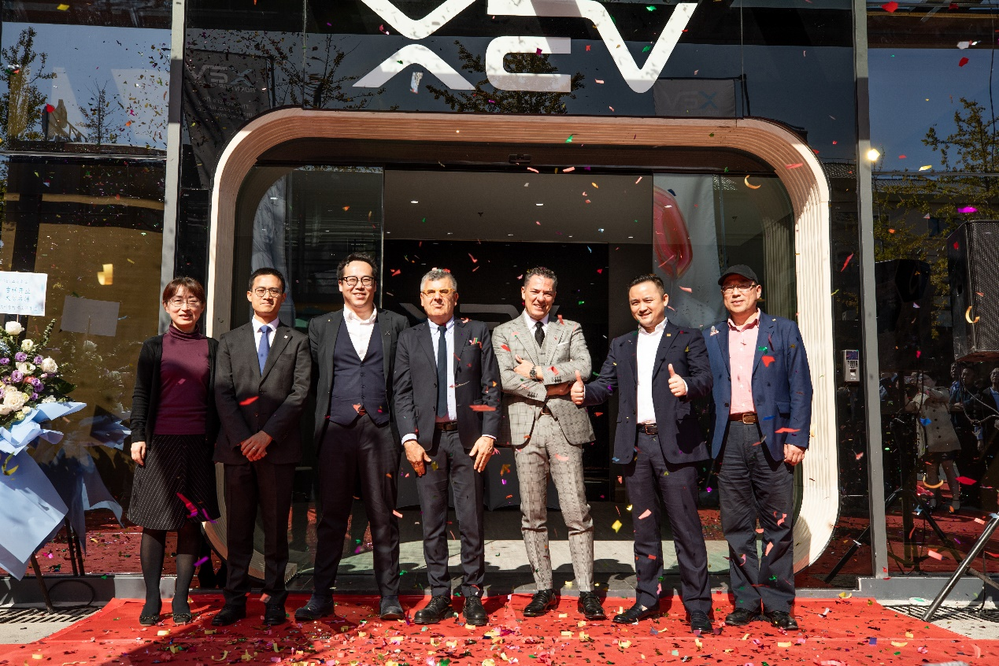
XEV Shanghai Center grand opening, ribbon-cutting guests in order from left to right are :Ms. Hu Haiyan, Vice Mayor of Shanghai Gucun Government, Mr. Huang Yu, President of Intesa Sanpaolo Shanghai Branch, Mr. Lou Tik, Fouder and CEO of XEV, Dr. Pagani, Technical Counselor of Consulate General of the Republic of Italy, Mr. Andrea Campello, CEO of Campello Auto, Mr. Yin Kun, Chairman and CEO of China Fortune Ocean Investment Fund, and Mr. Chen Jian, Chairman and General Manager of Shanghai Wisdom Bay Investment Management Company.

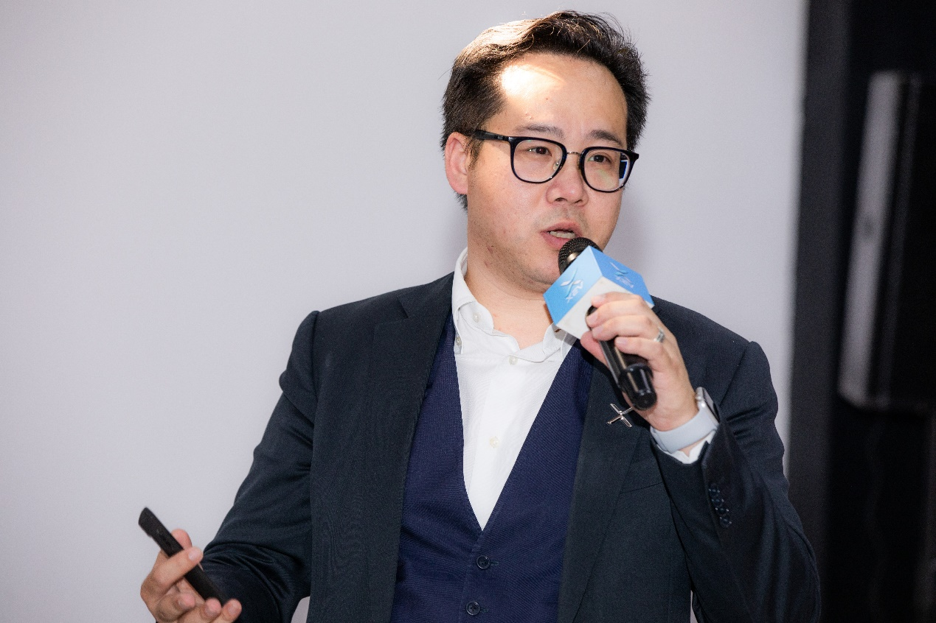
XEV founder & CEO Mr. Lou Tik gave a keynote speech at the opening ceremony of the Shanghai Center
Mr. Lou Tik, Founder & CEO of XEV, said “Aimed at integrating the best resources in the world for our prospective development in 3D printing vehicles, XEV Shanghai Center will be one of our three global innovation centers.

The core values of XEV lie in three bullet points: Customized 3D Printing for Everyone, Production with Fewer tools and waste, Rapid Hardware Iteration with Zero Cost. With the advantage in customization and flexible production, our technology needs no mold or large-scale stamping and casting facilities, and thus saves R&D time and cost, and satisfy the requirements from different customers and users. “
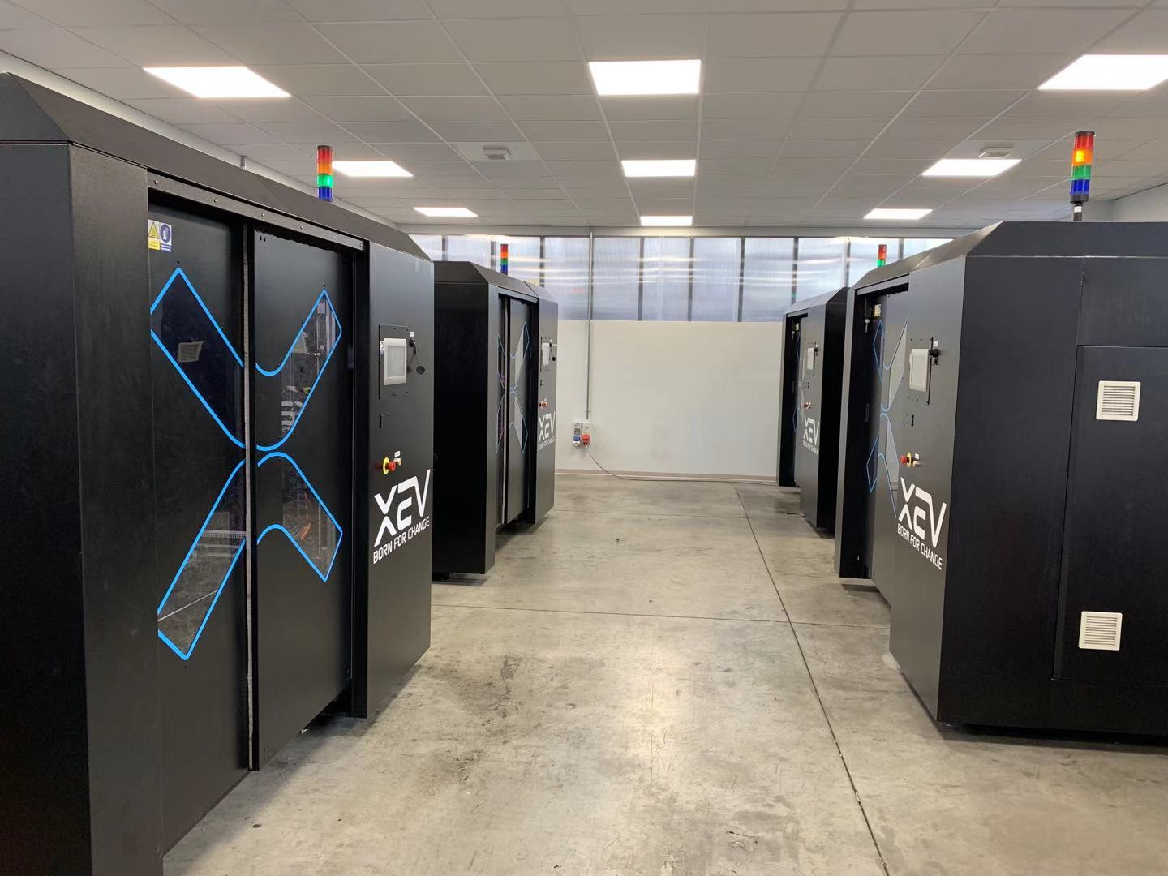

During the past few months in 2019, XEV has already signed exclusive strategic partnership with world-leading 3D printing material supply Polymaker, industry-level 3D printer manufacturer tycoon ATMAT, as well as Coin Robotics from China. With joint forces together, a complete solution from automobile-level 3D printing material, to large-scale industrial 3D printer then mass production of vehicles.​
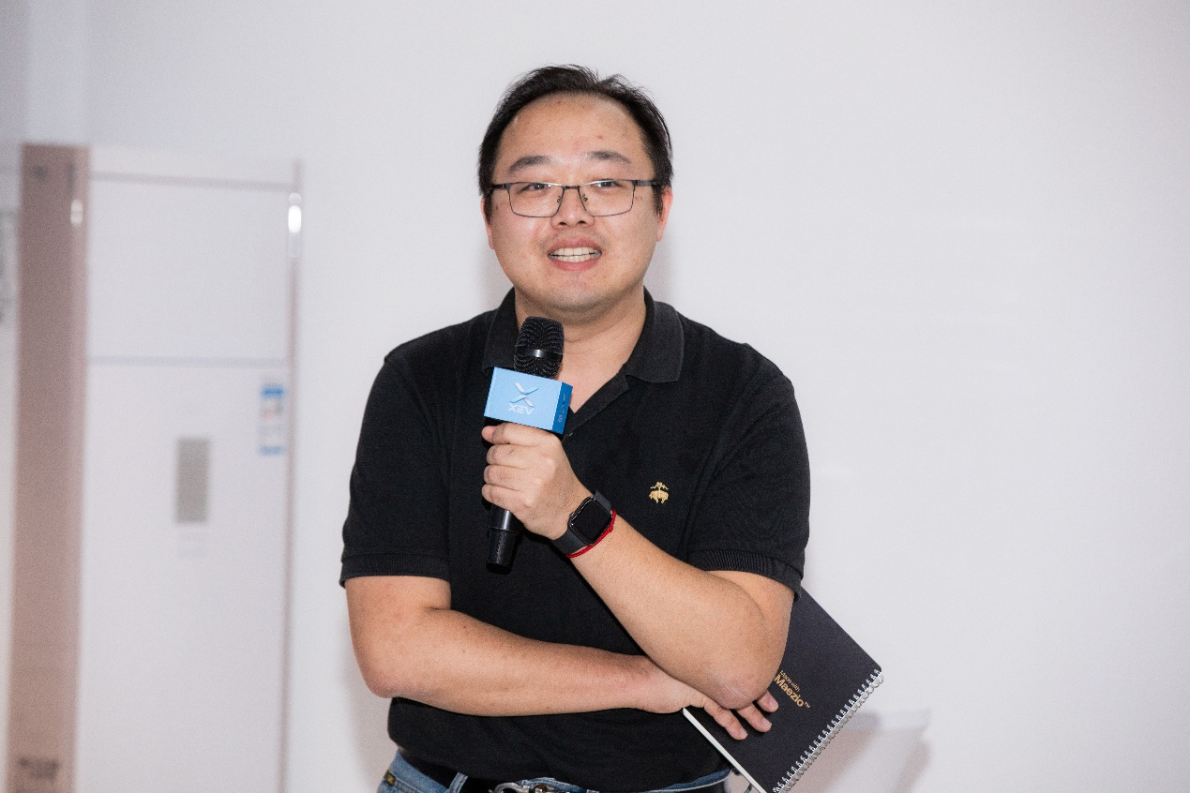
Mr. Qu Hang, Vice General Manager of Polymaker

Mr. Qu Hang, Vice General Manager of Polymaker, said “Mass production is no doubt the future, and XEC first brought this future to the world. As the exclusive 3D printing material supplier for XEV, Polymaker is keen to partner with XEV for developing 3D printing materials of better performance and contribute to this creative journey of 3D printing cars.

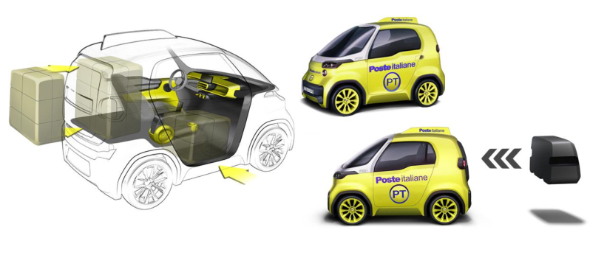
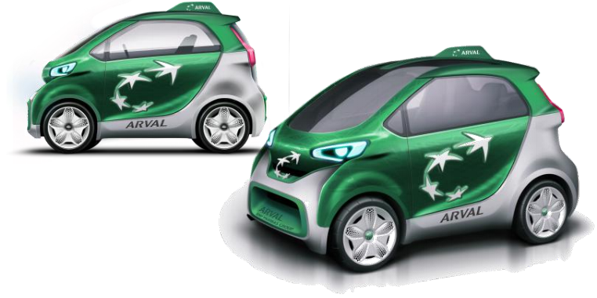

Thanks to rapid design customization, XEV has already received 7000 orders from Poste Italiane and ARVAL. Meanwhile, the mass-production model made for personal drivers will be distributed by two of the biggest names in an auto dealership, Campello Auto and Ascon Auto, making it easier for customers to reach.
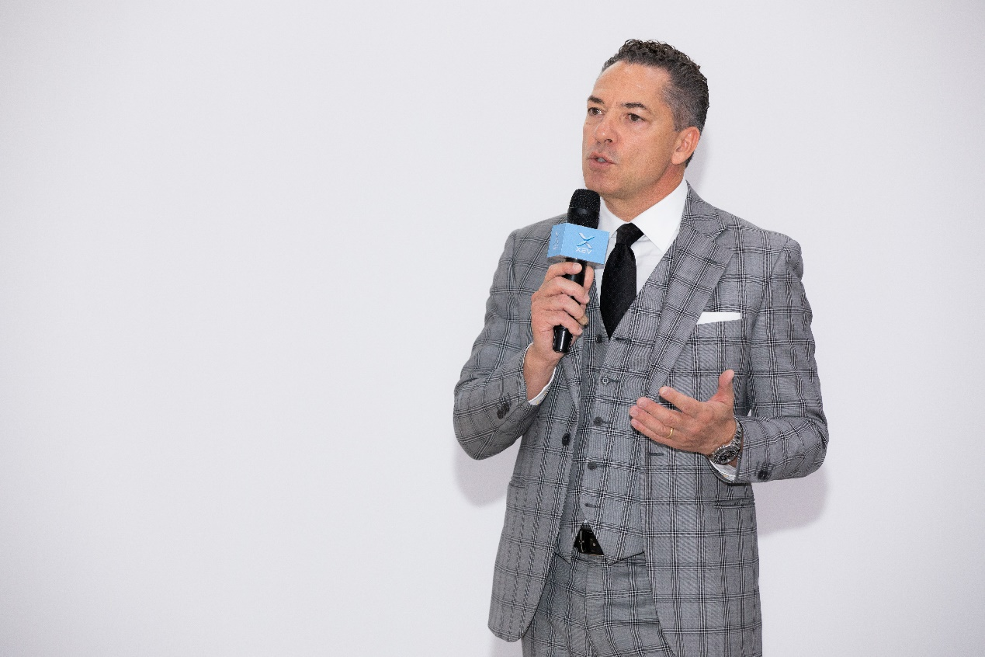
Andrea Campello, CEO of Campello Auto

Andrea Campello, CEO of Campello Auto, said “XEV’s product has great advantages in design and price. We are honored to be its partner in Europe. In two years, we are confident in selling more than 10 thousand YOYO vehicles every year in Italy.”
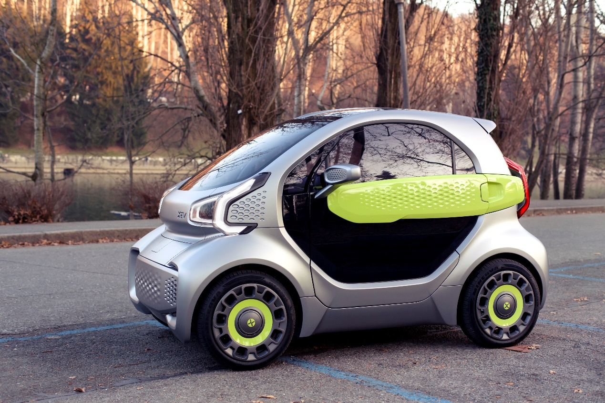
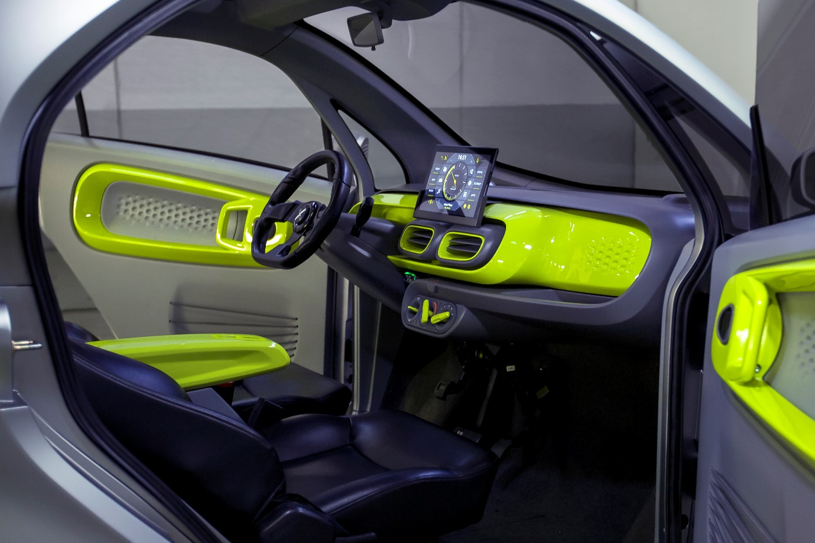
The prototype of Yoyo, XEV’s first mass-production model

Currently, XEV is busy preparing for the mass production of YOYO, its first model, with the strong support of investors including China Fortune Ocean Investment Fund.

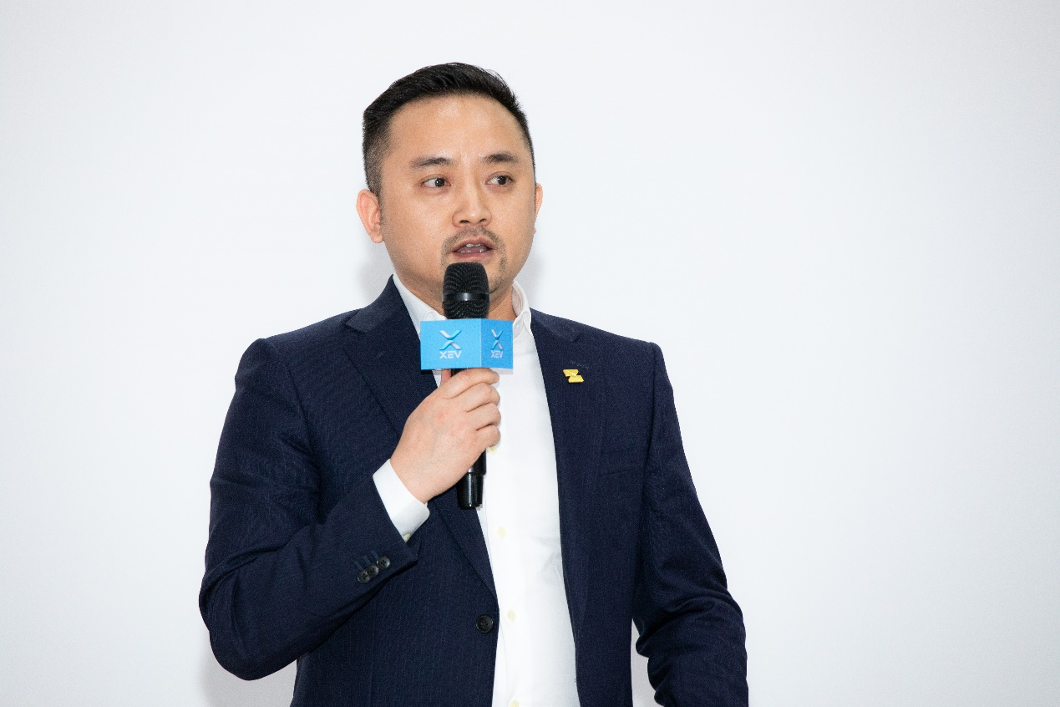
Mr. Yin Kun, Chairman and CEO of China Fortune Ocean Investment Fund

Mr. Yin Kun, Chairman & CEO of China Fortune Ocean Investment Fund, said:” Mr. Lou Tik and his team in XEV is abundant in innovation spirit and abilities, changing people’s perception on car body customization, and breaking the obstacles for optimizing the whole process of design, R&D, and manufacturing.”

Heading for SOP, XEV will join forces with leading OEM in China and manufactures around 10 thousand vehicles every year that are scheduled to role out from Q4 in 2020. With its leading 3D printing additive manufacturing technology and innovative customization business model, XEV is dedicated to reshaping the NEV industry, creating better value for people and society.

About XEV

XEV（ X-Electrical Vehicle）is an auto manufacturing company that possesses both the core technology of 3D printing and familiarities for the Internet. The company mostly deals with the manufacturing and sales of premium BEV passenger cars as well as R&D of 3D printing facilities. The product covers small-size mobility tools including electrical sedan, SUV, and MPV. Focusing on 3D printing technology, XEV wants to build a whole circle for the automobile ecosystem and to create the ultimate user experiences in mobility.

